**Blending. Pitchforks at ASU Tempe decided to start a cake business in the campus as there are lot of student birthday’s, graduations going on. To start with, they decided in baking two types of cakes: red velvet and tiramisu both of which consists solely of flour, sugar and butter. Currently they have 10,000 ounces of flour, 2000 ounces of butter, and 3000 ounces of sugar. The batter used in making red velvet must contain at least 20% butter, the batter used in making tiramisu must contain 10% butter and 10% sugar. Each ounce of red velvet can be sold for $1.4 and each ounce of tiramisu can be sold for $1.2. Determine how they can maximize their revenue from selling cakes.**

**Discussion.**

This is an example of a blending problem where a particular product is a mix of two or more materials. Here, there are 2 types of cakes, each made from a mixture of flour, butter, sugar. We have the requirement that at least a certain fraction of each cake of each type must be composed of a specific material. Since we have the available ounces of each material, the decision variable must be how many ounces of each material must be allocated to produce a cake type. The sum of materials for each cake type can be assumed to be the number of units of each cake type sold. This derived number of units of cakes sold can be used to find that total revenue, which must be maximized according to the objective. The constraints are clear that the total material allocated for both cake types must be within the available ounces of that material and the minimum fraction of a particular material needed in a cake type must be satisfied while allocating materials.

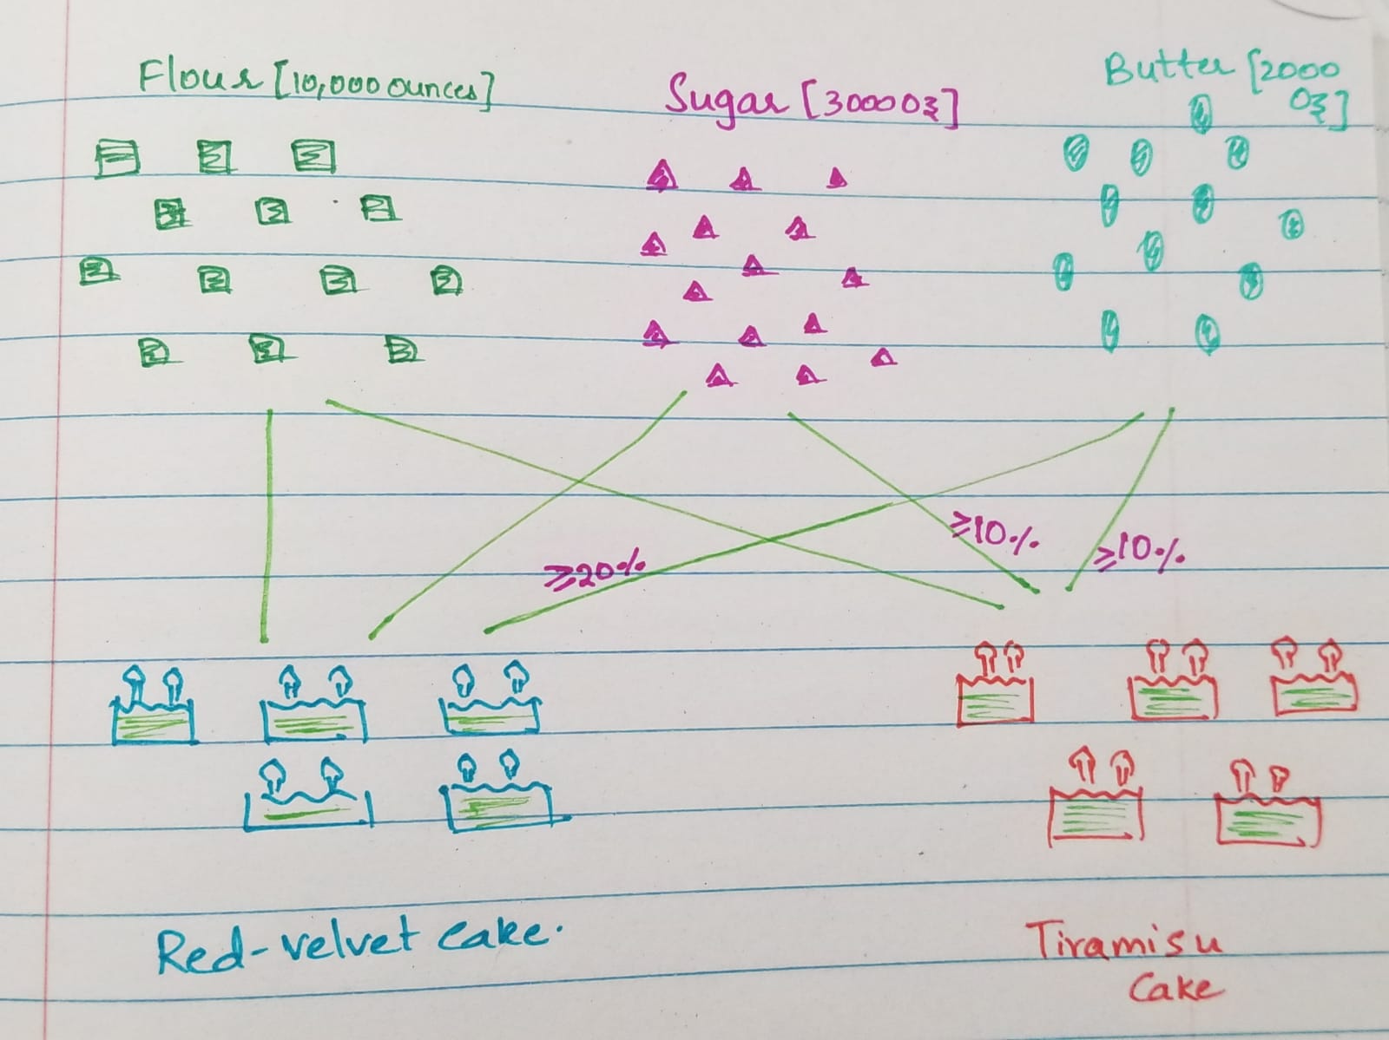

**Model.**

Parameters:

$S_{C }$: *Selling Price of cake type $c$, $where c∈\left(Red Velvet, Tiramisu\right)$*

$F_{ic}$: *Minimum fraction of material $i$ to be present in cake type $c$, $where i∈\left(Flour,Sugar,Butter\right)$, $c∈\left(Red Velvet, Tiramisu\right)$*

$A_{i }$: *Availability of material $i$, $where i∈\left(Flour,Sugar,Butter\right)$*

Decisions:

$x_{ic}$: *Ounces of material $i to$ to be allocated to cake type $c$, $where i∈\left(Flour,Sugar,Butter\right)$, $c∈\left(Red Velvet, Tiramisu\right)$*

Objective: *Maximize Revenue*

$max\sum_{c∈\left(Red Velvet, Tiramisu\right)}{ }$ $x_{ic}$ ${ S}_{C}$

*

Constraints:

$x_{ic }≥0 \left(1\right)$ Non- negative allocation

2) Satisfy minimum percentage of each material units of in each cake type

$\sum_{c}{x_{ic }}{≤A}_{i }$ (3) Maximum availability of materials.

Notes:

1. Constraint (2) ensures that units of each cake type has the required percentage of materials mentioned. It is important to denote this equation in a linear format, i.e., a decision variable cannot be present in a denominator of the fraction. It is natural to write this constraint as $x_{ic} /\sum_{i}{x_{ic }}≥ F_{ic}$,which is a non-linear representation, since a decision variable is present in the denominator. To convert this to the linear format, simply move this denominator to the right-hand side of the equation to get constraint (2). Below the implications of a linear representation when using simplex solver is illustrated. It is important to note that the simplex solver computes the optimal solution by checking only the boundary points of the feasible region.

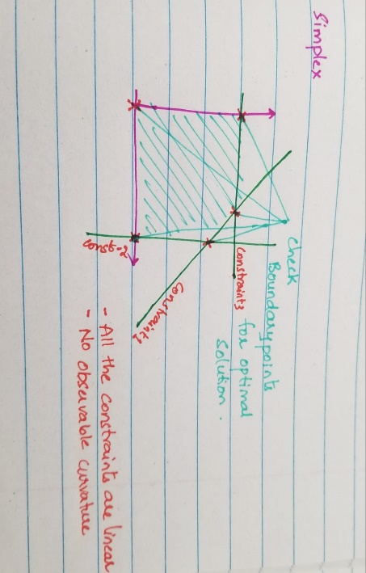

1. Constraint (3) ensures the total of each materials among the 2 cake types stays within the availability if that corresponding material

**Optimal Solution.** The following is the solution obtained from Excel Solver.

